Physical Therapy Connections, PC
October 2013
Breakfast & Nutrition Seminar
Join Adrian Gomez & Guest Speaker Jo Schrubbe (Certified Nutritionist)
$10.00 per person

Monday, November 4th, 2013 @ 5pm
58 Glenroyal Dr. Pueblo, CO 81005
888-565-1105

Exercise of the Month
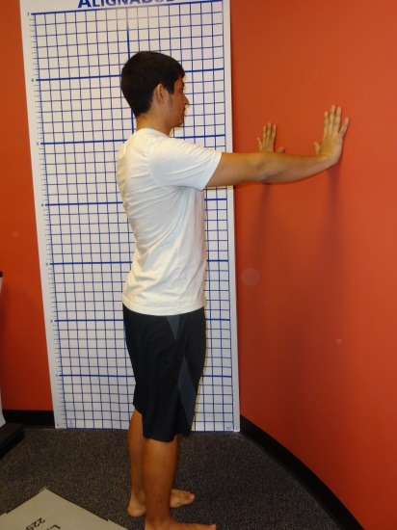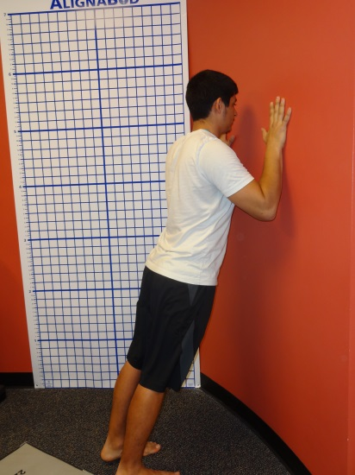
Wall Pushes

What’s Going on @ PTC?
Alright guys and gals pay attention- Physical Therapy Connections is offering Wellness Classes 9x every week. You can join in the fun and learn new ways to exercise and much more about our wellness programs. What is Wellness? Exercise? Nutrition? Stress? Sleep? Hydration? Mood? Energy?
We want to promote healthy lifestyles and encourage weight loss, muscle gain, better balance, better fitness, a better YOU!
This is not a contest between you and other participants but rather, a progression so that you may better yourself.

Get up and get in here! Thank you for your participation with our monthly newsletter if you have a friend or family that wishes to receive our monthly newsletter please call or email us today!
RSVP now! 888-565-1105
bryce@pt-connections.com
www.PT-Connections.com

